**MCFC AGM 1980**

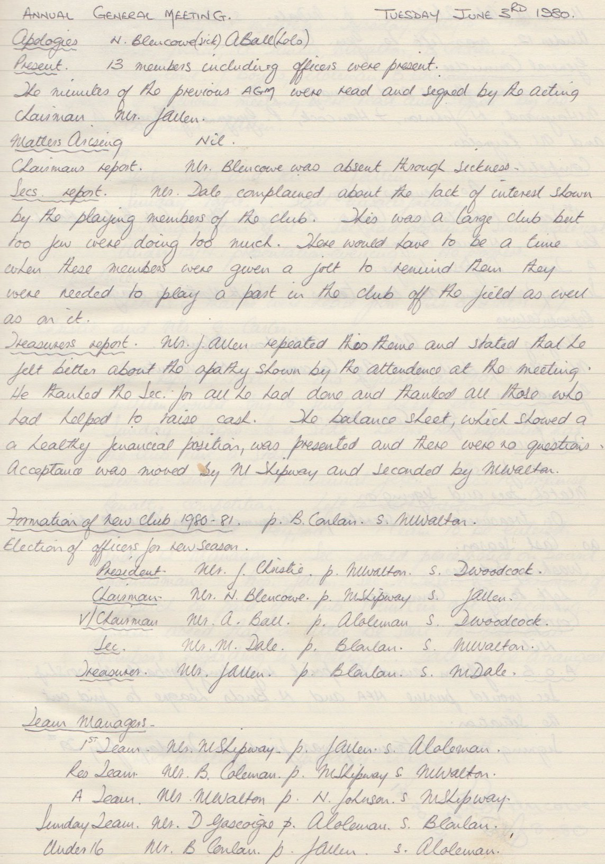

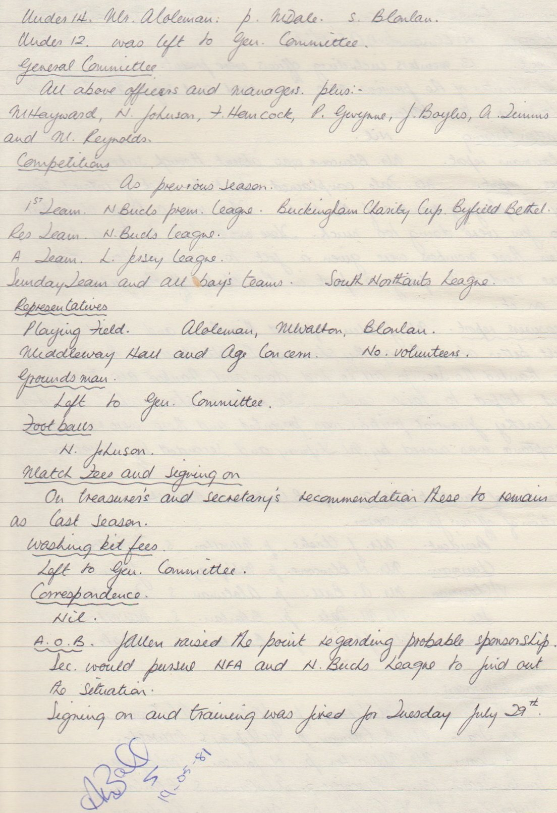

**General Committee Meeting**

**July 15th 1980**

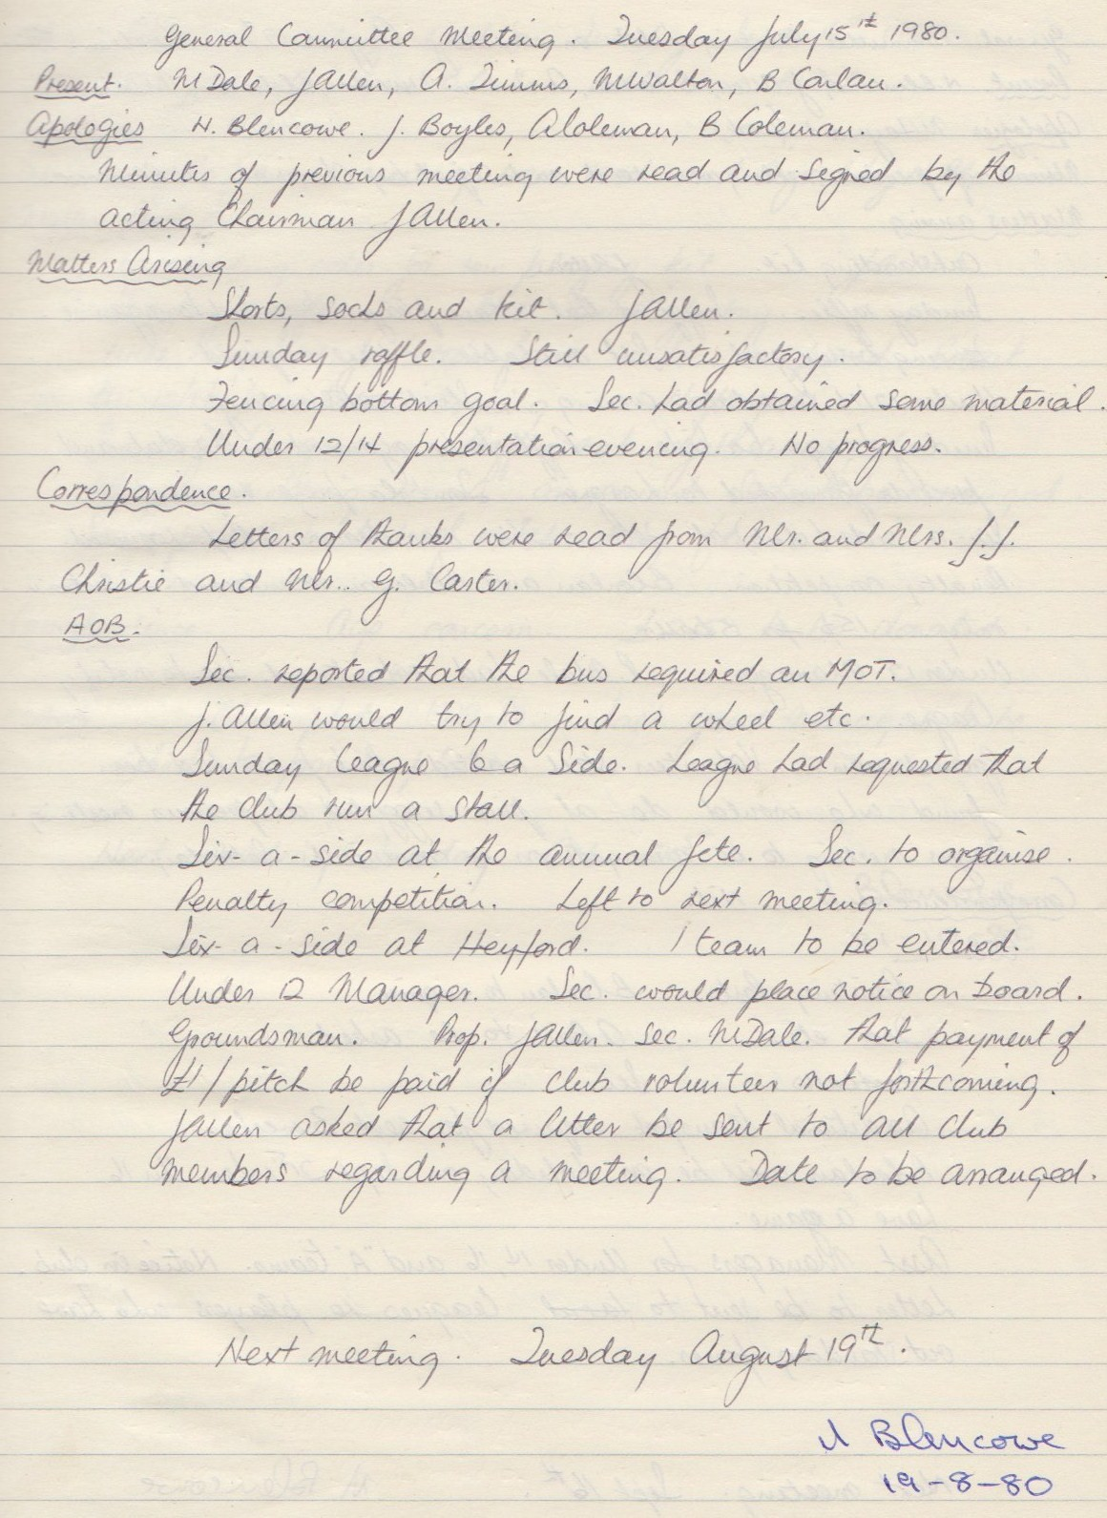

**General Committee Meeting**

**August 19th 1980**

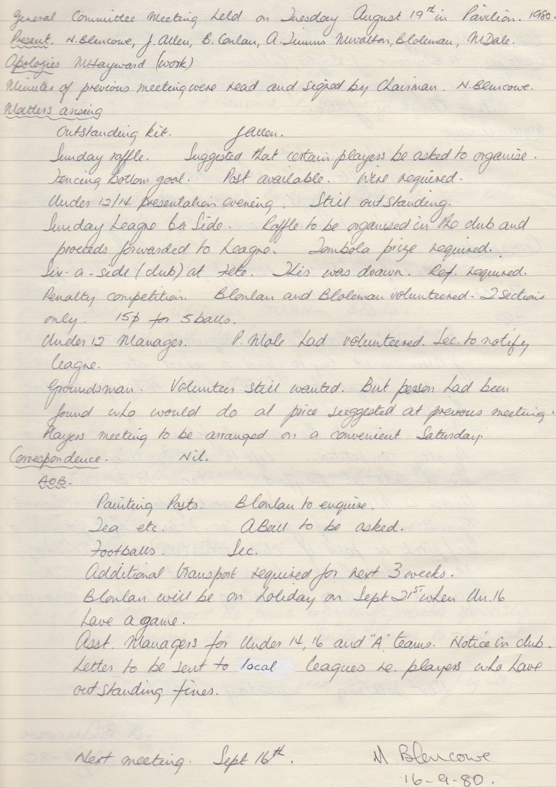

**General Committee Meeting**

**September 16 th 1980**

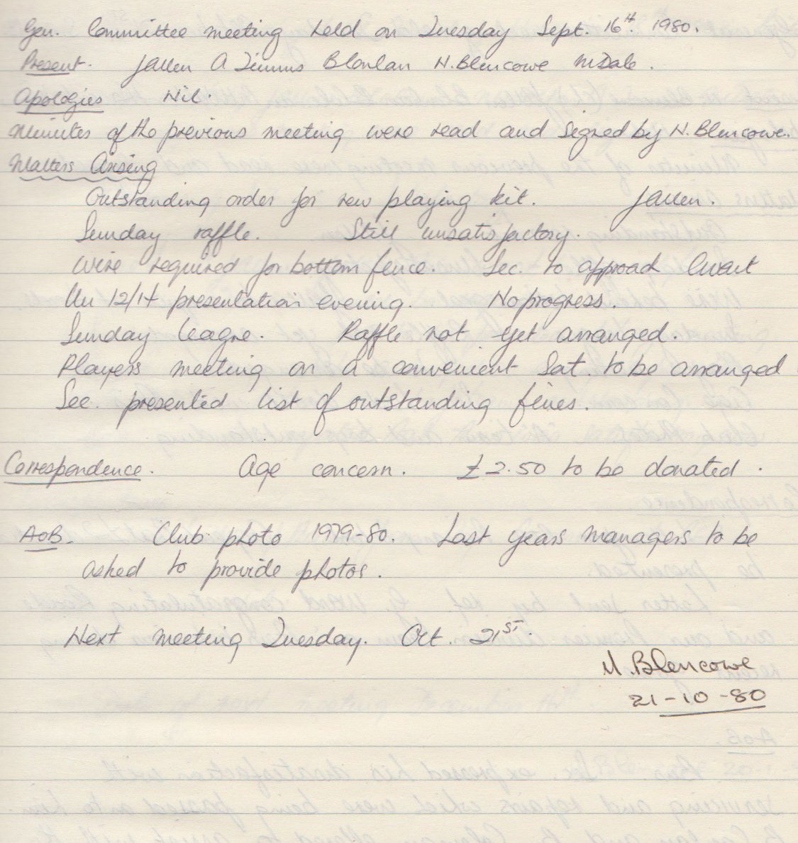

**General Committee Meeting**

**October 21st 1980**

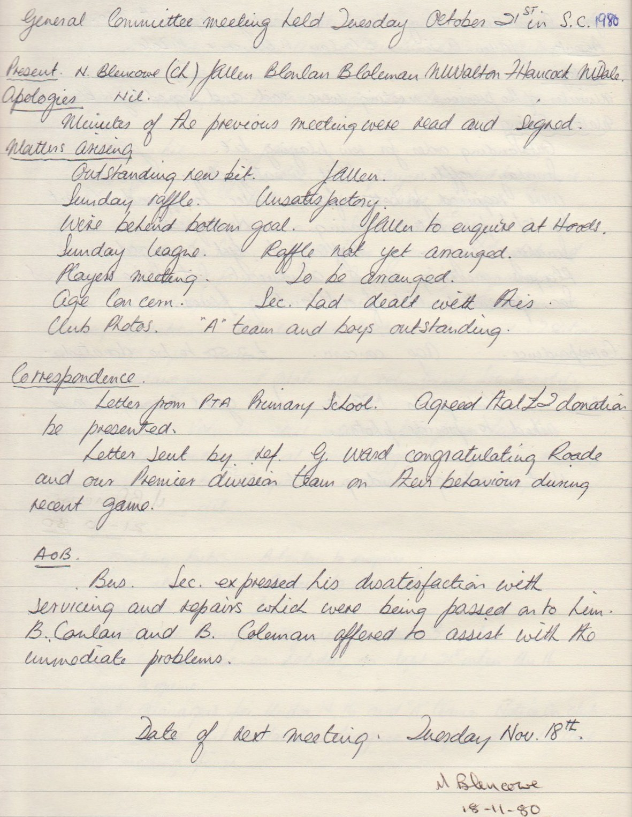

**General Committee Meeting**

**November 18th 1980**

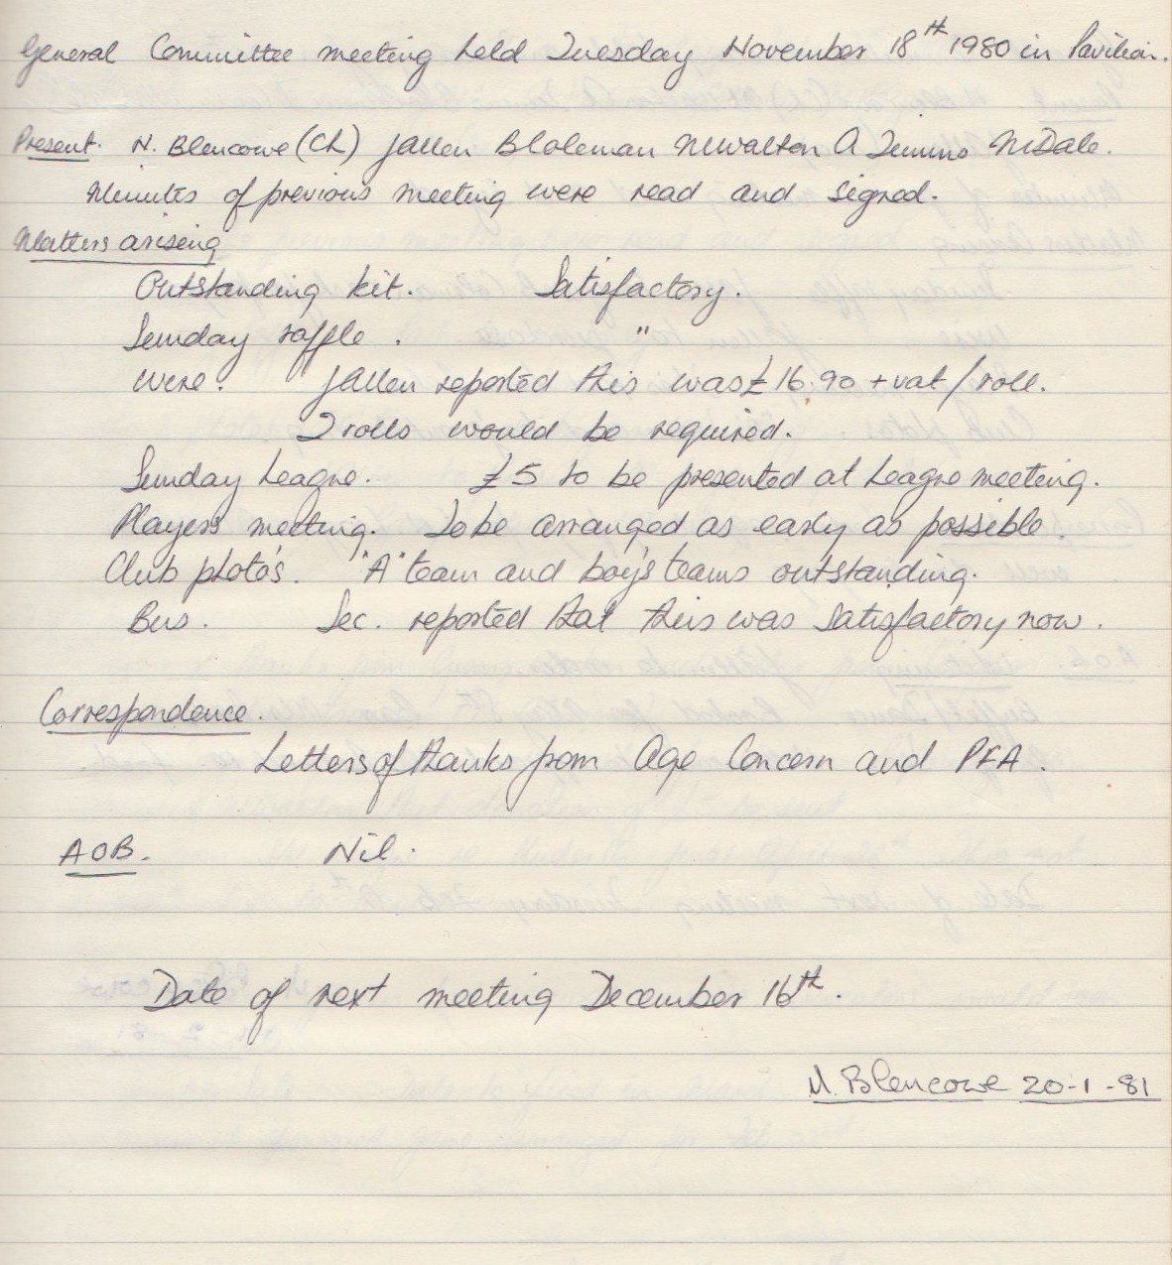

**General Committee Meeting**

**January 20th 1981**

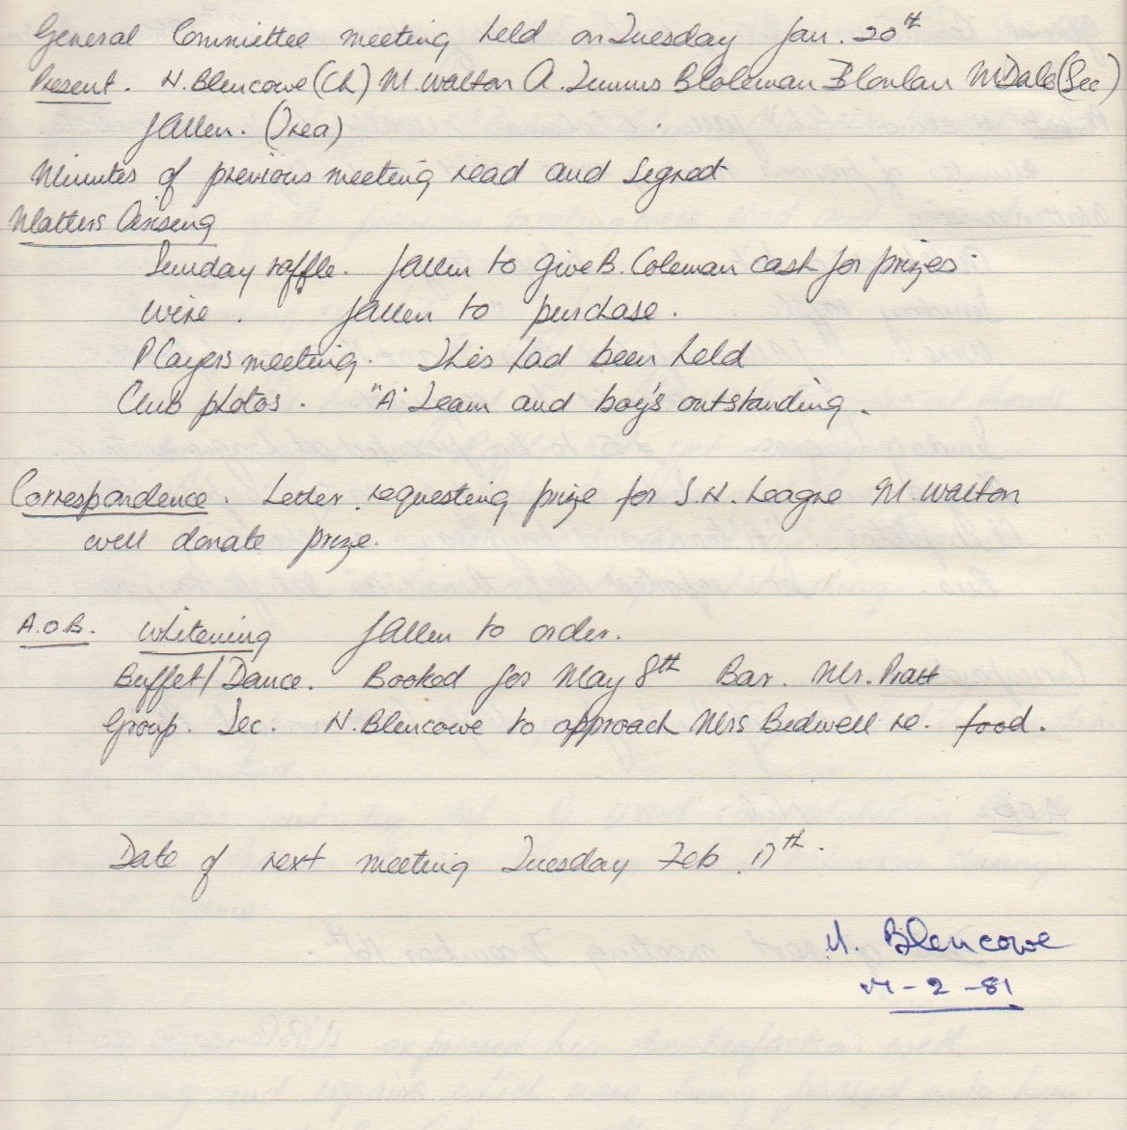

**General Committee Meeting**

**February 17th 1981**

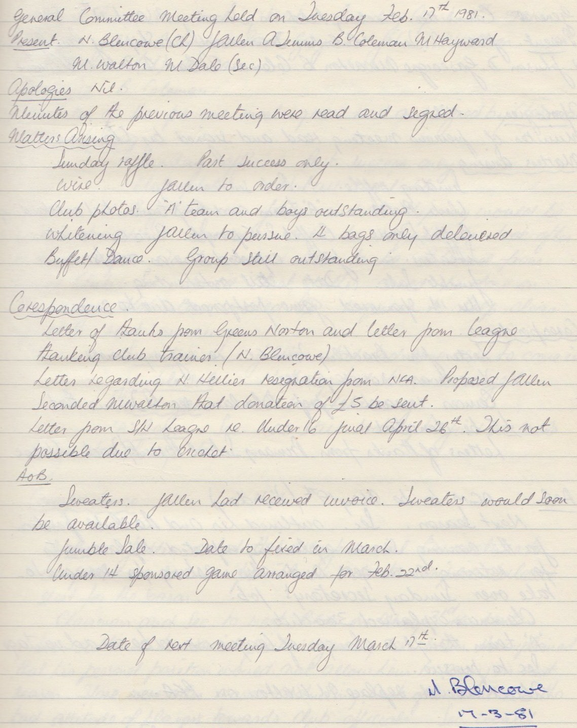

**General Committee Meeting**

**March 17th 1981**

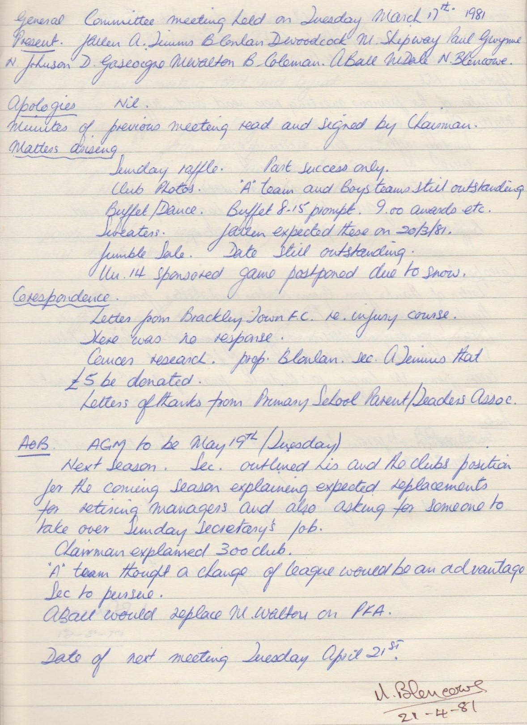

**General Committee Meeting**

**Aprill 21st 1981**

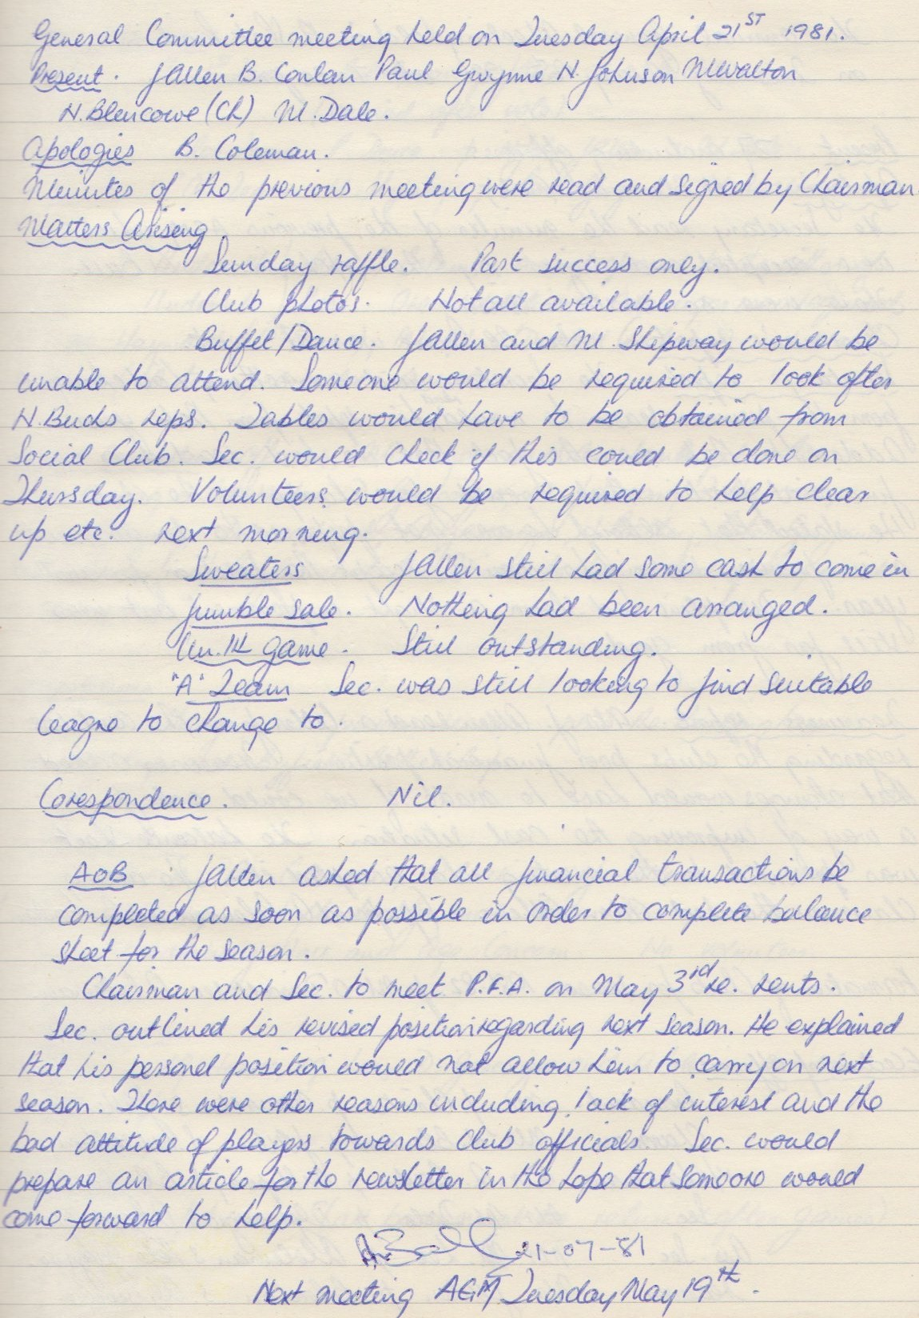

**General Committee Meeting**

**April 21st 1981**

